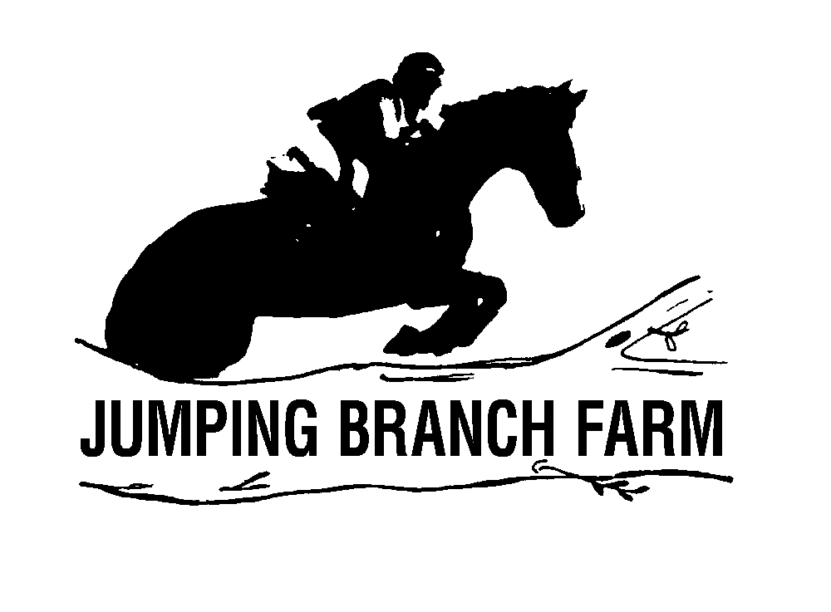
Jumping Branch Farm
Schooling Horse Trial
September 17, 2022
Opening Date: August 1, 2022 Closing Date: September 13, 2022
Please enter through: www.evententries.com. Entries will be limited to 150 riders.
OFFICIALS

Hosts: Tim and Vickie Shaw
TD/POGJ/SJ Course Design: Michelle Brochu
XC Design: Bonnie Mosser
Dressage Judges: Mo Martell & TBD
Show Jump Judge: Janice Keats
Paramedic: Cathi Grove
Manager/Secretary: Amber Lee
Volunteer Coordinator/Control: Melissa Rundt
Day of Secretary/Scoring: Megan Stauch
Photographer: Christine Quinn Photography
Food Vendor: Uprooted Vegan Cuisine
Announcer: John Bandrofchek
Horse Trials: $150
Combined Test: $75
Divisions: Starter (2’3”), Beginner Novice (2’7”), Novice (2’11”), Training (3’3”)
Stabling: $75/night (bedding included) RV Hook-up: $30/night/30amp
*ALL RV RESERVATIONS MUST BE MADE BY EMAILING timshaw628@gmail.com.
Refunds: Scratches received prior to the closing date will be refunded, less $25 office fee. No refunds after the closing date. If for any reason the show if canceled – partial credit applied. After closing date, refund minus $25 office fee, only if same spot can be filled from wait list (if there is a wait list).
Change Fee: $25 Non-compete Horse: $50 Returned Check Fee: $50
Late Fees: Entries received after the closing date will be subject to a $25 late fee for the Horse Trials. Entries must be accompanied by payment to be processed. Entries received without payment will not be accepted.
HORSE TRIAL AND COMBINED TEST DRESSAGE TESTS - (20m x 40m) Small Arena
Starter: USEF 2022 Starter Eventing Test
Beginner Novice: USEF 2022 BN Eventing Test B
Novice: USEF 2022 Novice Eventing Test B
Training: USEF 2022 Training Eventing Test B
OTHER INFORMATION
Dressage and Stadium Jumping will be on Grass Footing.
Ride Times & Stabling Chart will be available at www.JBFarm.com and Event Entries September 15th.
Riders may wear cross-country attire and gear for show jumping.
Medical armbands, safety vest and ASTM approved helmets are required.
Show Coats & Braiding not encouraged.
All dogs must be leashed.
Levels may be divided/combined if entries warrant.
The competition will be held in accordance with current USEA and USEF rules.
Valid negative Coggins within last 12 months required.
AWARDS
Ribbons awarded 1st through 6th place.
SCDCTA & TIP Recognized.
Oak Manor Saddlery Bonus Bux.
Prize Money: Suzy Haslup of Aiken Horse Realty, Meybohm has generously offered $250 in prize money to the top placing OTTB. Also, a Leather Halter for top overall and Saddle Pad to second place overall winners.

Jumping Branch Farm
Schooling Horse Trial
September 17, 2022
Opening Date: August 1, 2022 Closing Date: September 13, 2022
Please enter through: www.evententries.com. Entries will be limited to 150 riders.
Rider Name: __________________________________________________________________________
Horse Name: __________________________________________________________________________
Owner Name: ________________________________ Trainer Name: ___________________________
Division: Starter Beg Novice Novice Training
Eligibility: Amateur Rider Horse Open Jr/YR
Address: _____________________________________________________________________________
City: ________________________________________ State: ______________ Zip Code: ___________
Phone #: ____________________________________ Email: __________________________________
Emergency Contact: ___________________________________ Phone #: _________________________
Entry Info | Fee | Quantity | Total
Horse Trial | $150
Combined Test | $75
Stall | $75
RV Hook-up (30amp) | $30
RV Hook-up (50amp) | $40
Noncompete Horse | $50
Late Fee | $25
One Entry per Horse. Please make checks payable to JBF or Venmo Vickie-Shaw-3
ALL RV RESERVATIONS MUST BE MADE BY EMAILING timshaw628@gmail.com.
Mail or email entries to:
Jumping Branch Farm • 179 Fox Pond Rd • Aiken, SC 29801
aelee28@gmail.com • (803) 260-5970 • www.JBFarm.com

